
Suspensions & Exclusions Policy

Little Runners will deal with negative and inappropriate behaviour by using constructive behaviour management techniques. We will involve staff, parents and children to tackle disruptive and challenging behaviour collectively. We acknowledge that some children will require additional support in order to achieve acceptable levels of behaviour. Where we identify a child with these needs, we will work closely with the parents or carers to deal with the inappropriate behaviour in accordance with our Children’s Behaviour Management policy.

Staff will inform the manager if a child’s behaviour warrants suspension or exclusion.

We will only suspend or exclude a child from the Club as a last resort, when all other behaviour management strategies have failed or if we feel that children or staff are at risk. Suspensions and exclusions will be fair, consistent and appropriate to the behaviour concerned, and will take account of the child’s age and maturity as well as any other factors relevant to the child’s situation. If appropriate, we will seek advice from other agencies; this may include accessing funding for additional support.

A child may be suspended or excluded if they:
- Pose a serious risk to the health, safety, or wellbeing of themselves or others
- Display persistent disruptive or challenging behaviour that does not improve despite appropriate interventions
- Engage in physical violence, bullying, or threatening behaviour
- Cause serious damage to property
- Use discriminatory or abusive language or behaviour
Suspension or exclusion will not be based on:
- A child’s disability, special educational needs, race, gender, religion, or family background
- Behaviour that is developmentally appropriate without prior support and intervention
Temporary suspensions

Temporary suspensions will be applied if inappropriate behaviour continues after parental consultation and 5 Behaviour Record entries, (where formal warnings have failed to improve a child’s persistent, challenging and unacceptable behaviour).

OR

In the event of an extremely serious or dangerous incident we will suspend a child with immediate effect. We will contact the parents and ask that the child be collected immediately. Immediate suspensions require the manager’s agreement.

- Parents/carers will be informed verbally and in writing of the reason for suspension
- The length of the suspension will be clearly stated (normally no longer than 5 sessions)
- The child’s place may be held during suspension, subject to the club’s terms and conditions
- A reintegration meeting will take place before the child returns to the club

Exclusion Procedure
- Exclusion will only be considered after all reasonable alternatives have been exhausted
- The decision will be made by the Club Manager/Director
- Parents/carers will receive written notification explaining the reasons for exclusion, following a face-to-face meeting
- Information will be provided about any right to appeal or make a complaint

Safeguarding and SEND Considerations
- The club recognises that challenging behaviour may be linked to unmet needs or safeguarding concerns
- Additional support and reasonable adjustments will be explored for children with SEND
- Safeguarding concerns will be reported in line with the club’s Safeguarding Policy

Appeals and Complaints

Parents/carers may appeal a suspension or exclusion by:
- Submitting a written appeal within 10 working days
- The appeal will be reviewed by a person or panel not directly involved in the original decision
- A written outcome will be provided

Record Keeping

The club will maintain confidential records of:
- Incidents leading to suspension or exclusion
- Communication with parents/carers
- Decisions made and actions taken
Records will be stored securely in accordance with data protection requirements.

This policy was adopted by: Little Runners | Date: 14/02/2026
To be reviewed: Sept 2026 | Signed: [by Directors]  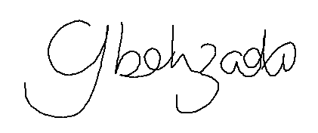Cassie Behzadi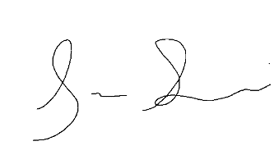Bobby Behzadi

